**PHASE 2**

**TOPIC:Series of forecasting techniques like Prophet or deep learning models for improved accuracy in predicting future electricity prices.**

**Exploring more advanced time series forecasting techniques like Prophet or deep learning models can indeed improve the accuracy of predicting future electricity prices. Here's an overview of how you can leverage these method**s:

1.Prophet:

Introduction**: Prophet is an open-source forecasting tool developed by Facebook that is specifically designed for time series forecasting with daily observations that display patterns on different time scales.**

Advantages**: Prophet is easy to use and can handle missing data and outliers gracefully. It also provides the ability to incorporate holidays and special events as part of the forecast.**

Usage: **You can implement Prophet in Python or R. It requires historical time series data as input and allows you to specify seasonality, holidays, and other relevant factors.**

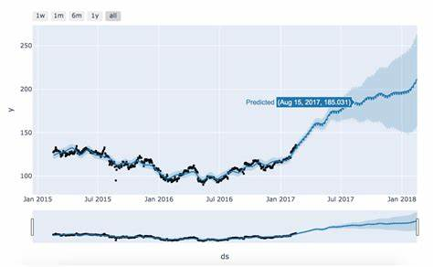

**FIG 1: https://h1ros.github.io/posts/prophet-101-a-time-series-forecasting-module/**

**2**. **Deep Learning Models:**

Introduction**: Deep learning models like recurrent neural networks (RNNs) and Long Short-Term Memory networks (LSTMs) have shown significant success in time series forecasting tasks.**

Advantages:  **Deep learning models can capture complex patterns and dependencies within the time series data, making them suitable for tasks where traditional methods may fall short.**

Usage**: Implementing deep learning models for electricity price forecasting typically involves preprocessing the data, defining the model architecture, and training the model using historical data. Libraries like TensorFlow and PyTorch are commonly used for this purpose.**

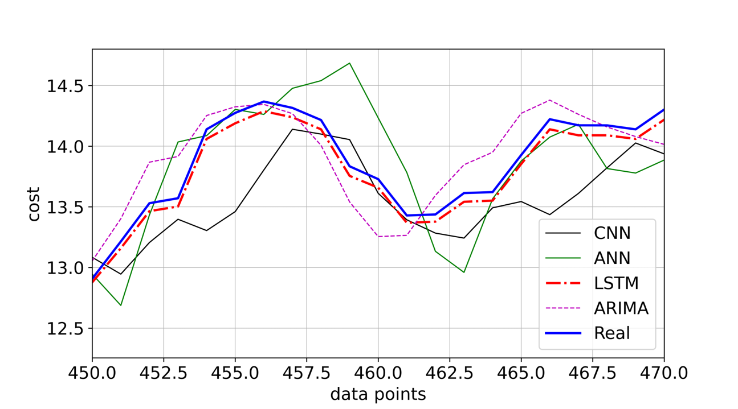

**FIG2:** [**https://awesomeopensource.com/project/abodh/Electricity-cost-forecasting-using-machine-learning-and-deep-learning-models**](https://awesomeopensource.com/project/abodh/Electricity-cost-forecasting-using-machine-learning-and-deep-learning-models)

**Here's a step-by-step approach to incorporating these techniques into your electricity price forecasting:**

1. Data Preparation:

Collect historical electricity price data, ensuring it's cleaned and properly formatted.

Split the data into training and validation sets for model evaluation.

2. Prophet Implementation:

* Install and use the Prophet library in your preferred programming language (Python or R).

*Configure the model, including specifying seasonality, holidays, and other relevant parameters.

* Fit the model to the training data and validate it using the validation set.

* Generate forecasts for future time periods.

3. Deep Learning Model Implementation:

*Choose a deep learning architecture, such as RNNs or LSTMs.

* Preprocess the data, which may include normalization and feature engineering.

* Define the model architecture using a deep learning framework like TensorFlow or PyTorch.

*Train the model using the training data and validate it using the validation set.

* Make predictions for future time periods.

4. Evaluation and Fine-Tuning:

*Evaluate the performance of both the Prophet and deep learning models using appropriate metrics (e.g., Mean Absolute Error, Root Mean Squared Error).

* Fine-tune hyperparameters to optimize model performance.

5. Deployment:

- Once you're satisfied with the model's performance, you can deploy it for making real-time or future electricity price predictions.

Remember that while these advanced techniques can provide more accurate forecasts, they also require a good understanding of time series data preprocessing, model tuning, and evaluation techniques. Additionally, you may need to gather domain-specific knowledge to enhance your forecasting results further.

THANK YOU